Lab 2 NISO – MaxSat Genetic Algorithm
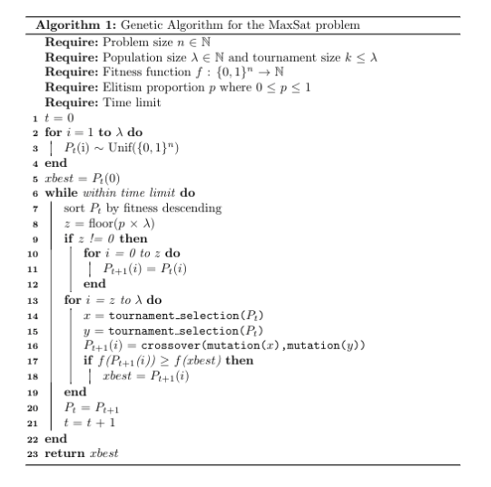

WCNF file: mse17-complete-unweighted-benchmarks/kbtree/kbtree9_7_3_5_90_6.wcsp.wcnf
Parameters: n = 280, p = 0.1, chi = 0.6, time limit = 25 seconds

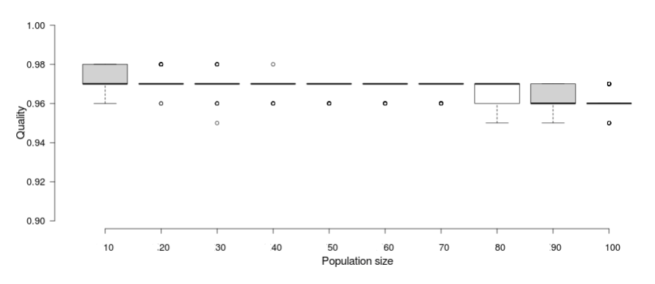

WCNF file: mse17-complete-unweighted-benchmarks/kbtree/kbtree9_7_3_5_90_6.wcsp.wcnf
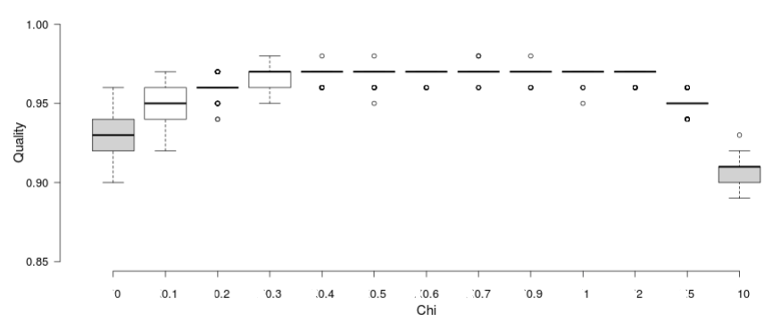
Parameters: n=280, lambda=50, p=0.1, time limit = 25 seconds

From these results, we can see that having a value of chi between 0.3 and 2 produced the best results. With no mutation at all, the best solution found was not as good as the values in the best range. This is because with no mutation rate, exploration of the search space is limited and fails at finding the local optimum. As we increase the mutation rate slightly, the algorithm finds what seems to be the optimum solution for this particular case. As the mutation rate increases to 5 and above, the algorithm starts turning into a random walk and the quality of the solution begins to suffer.

